**SCHOOL MANAGEMENT SYSTEM PROPOSAL**

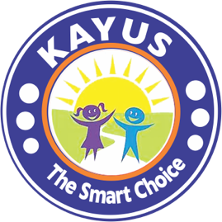

Submitted By:

ADMOTRON SOLUTIONS

opeyemiademon@gmail.com

08032950881

Table of Contents

1.0 EXECUTIVE SUMMARY 4

1.1 COMPANY INTRODUCTION 5

2.0 PRODUCT INTRODUCTION 6

2.1 MAIN FEATURES 6

a. Admission Processing System 6

b. Student Management System 7

c. Examination and Result Management 7

d. School Fees Management 8

e. Staff Management 9

f. Attendance System 9

g. Finance Management 10

h. Payroll Management 10

i. Library Management 11

j. Time Table Management System 11

k. Transport Management System 12

l. Hostel Management System 12

3.0 TECHNICAL SPECIFICATIONS 13

3.1 Summary of Functions 13

3.2 Testing, Installation and Training 13

3.3 Performance 14

4.0 PRODUCT ACTIVITIES 15

4.1 Term of Payment 15

4.2 Demo Version 16

5.0 KAYUS Portfolio 17

5.1 ADUVIE INTERNATIONAL SCHOOL 17

5.2 GAAT International School 18

5.3 PAGE SCHOOLS, APO 18

5.4 GREAT MINDS MODEL INTELLECTUAL ACADEMY 19

5.5 HASKE INTERNATIONAL SCHOOL, GORON DUTSE 19

5.6 THE HERITAGE SCHOOL OF EXCELLENCE 20

6.0 CONCLUSION 21

# 1.0 EXECUTIVE SUMMARY

We are pleased to submit a proposal for the implementation of KAYUS - A School Management System to automate your school's operations.

Technology has improved the quality of education in the digital age, parents travel through academic portals, which now function as the school's front entrance. Portals is also the face with which institutions' partners or associates interact. It's past time for us to integrate an interactive portal into your school to improve your school's operations, employee efficiency, student and parent happiness.

The catch is that, we are aware of the constant futuristic advances in technology and demands, we will be including up-to-date technology to increase your operations. Our goal is to use an Automated School Management System called **KAYUS** to automate your school's operations or upgrade your previous system to a more sophisticated one. We are convinced that our system will effectively handle your needs due to our required experience in the educational industry.

# 1.1 COMPANY INTRODUCTION

Admotron Solutions is one of the most rapidly expanding tech firms. It is staffed by young engineers who are both brilliant and nimble. With technical expertise and straightforward communication, these Experts create Client Oriented Systems. To assure great delivery, the company exclusively hires the best.

Admotron is a one-of-a-kind company that strives to provide a customized, inventive, and cost-effective proposition at all times. It follows up with a flawless on-time and on-budget delivery.

Our years of experience are a distinguishing feature. Financial institutions, family-owned enterprises, government owned institutions, non-governmental organizations, and individuals are among our clients. We'd appreciate it, if you could contact one of our existing clients, since we're convinced, you'll get nothing but excellent feedback.

Our pride lies in our after-sales customer care, which includes guarantees, employee training, and onsite and offsite support.

# 2.0 PRODUCT INTRODUCTION

KAYUS is a School Management System that automates a school's day-to-day operations. It is appropriate for Kindergartens, Primary Schools, and Secondary Schools. It's a tried-and-true interactive and user-friendly web-based system.

This is how it works: when you use KAYUS, an applicant, learners, an administrator, parents and staff will all have access to different web platform where they may execute only the tasks that are relevant to their jobs at the time. This means that School Administrators will have unrestricted access to the system and will be able to control all of the actions. Its capabilities can be increased to match the school's future needs as long as the process can be automated.

# 2.1 MAIN FEATURES

# Admission Processing System

The admission processing system is used to keep track of potential applicants. It enables schools to efficiently manage their admissions processes, including the creation of numerous applications with associated costs, as well as opening and closing dates. The module comprises of data such as:

1. 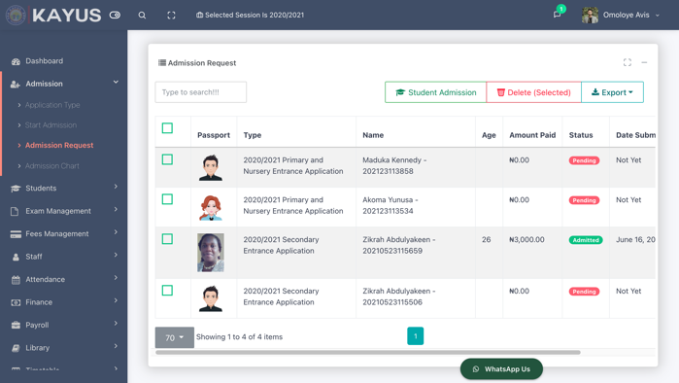Statistical data of Applicants
2. Online payment of Application Fees
3. Online Portal for Application Registration
4. Admission management

# Student Management System

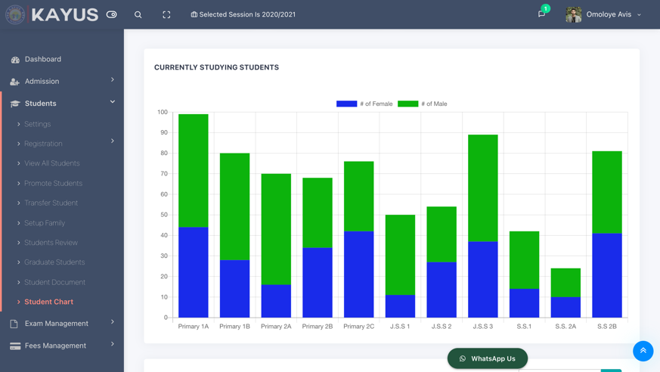This includes all sub system used to manage students records from the point of admission to the point of exit. It efficiently facilitates the creation and deletion of student records and other Management Functions. It includes sub-features such as:

1. Student Registration
2. Bulk Student Registration
3. Import Student Record from Excel File
4. Student Promotion
5. Student Transfer
6. Set Up Student Family
7. Student Review
8. Graduate Students
9. Student Profile
10. Student Statistics and many more

# Examination and Result Management

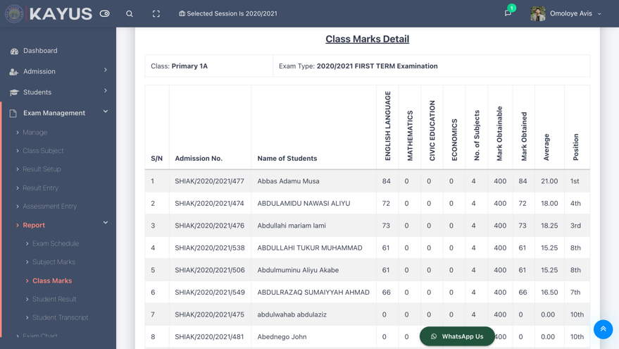The examination features allow you to add different exams such as First Term, Second Term, Mock Exam and so on, gets report cards and displays various student Termly reports including (1 C.A, 2 C.A, Exams etc). Most of the notable sub-system here includes:

1. Uploading of scores from excel,
2. subject result sheet at glance,
3. class result computation page,
4. locking & Unlocking of exams,
5. student terminal report, examination schedule,
6. student transcript.

# School Fees Management

When it comes to paying school fees, KAYUS is the most accommodating. Students can pay for their tuition either online or through a bank. Any designated Officer or the system Administrator can also record cash payments. KAYUS includes a provision for partial payment and creates a list of debtors. It allows for more control over the structure of school fees. School fees might be collected based on the status of the family, the student, or the class.

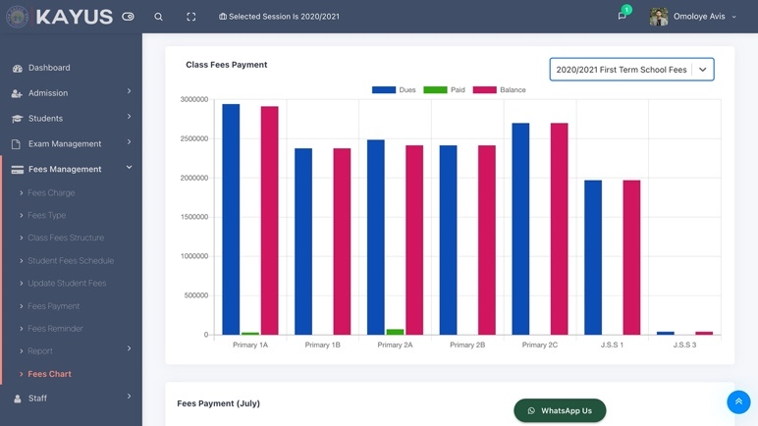Under this sub module one can

1. Set up fees /charges such as First Term Fees, Second Term Fees and more
2. Define Fee Type such as Laboratory Fees, Exam Fees, Data Capture and more
3. Setup different Fees for each class
4. Modify each student fees
5. Send reminder to debtors on a scheduled date
6. Online payment report
7. Generate Voucher and Cash Register

# Staff Management

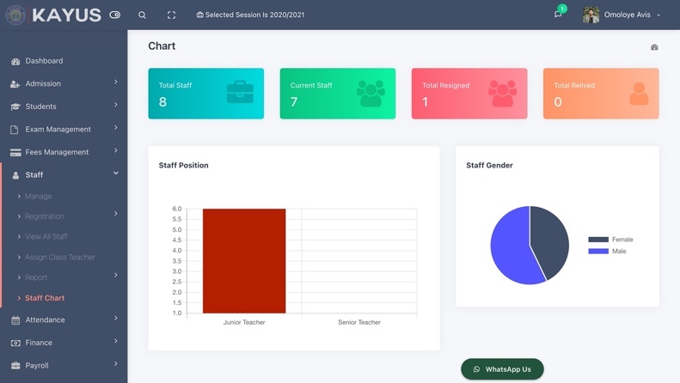This KAYUS Module holds the staff report, from staff registration to assigning employees to different departments and positions. It enables you to review staff status and display their profile. Most of these features are available for an Administrator.

# Attendance System

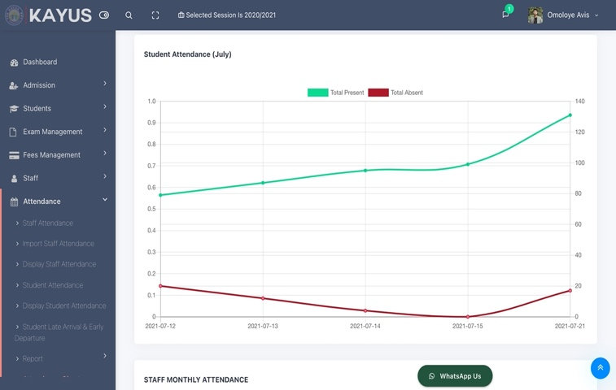Class teachers can use this tool to keep track of their pupils' daily attendance. It also tracks employee attendance and authorized users. It's a simple system that records the entire class's attendance with a single click. It indicates if you are present, absent, or half-day. If pupils are absent, it sends an automatic notification to parents and students on their registered mobile phones.

1. It displays the total number of times students are Present & absent on their terminal reports
2. Its records student’s late arrival and exact departure time.
3. It aggregates staff total monthly working hours.
4. It displays students and staff attendance summary

# Finance Management

This section contains all related Accounts activity. You can make a daily register, an income head, and an expenses head. Account balances and account statements are simple to obtain. It allows the designated user to keep track of both income and expenses.

With Finance one can:

1. 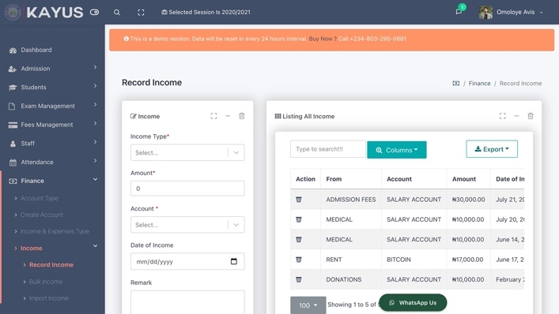Record bulk Income and expenses
2. Import Bulk Income or expenses from Excel File
3. Create Multiple accounts
4. Display other financial records

# Payroll Management

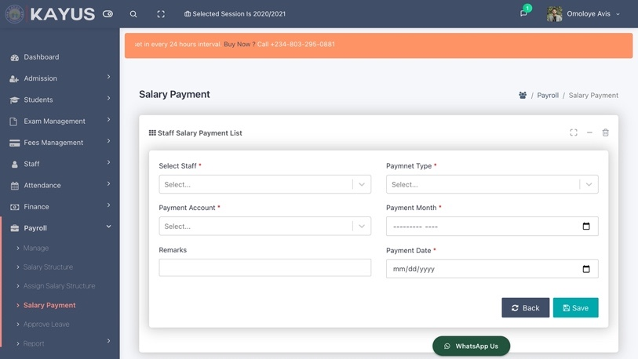Almost all relevant HR Activities are provided into the Payroll Module. You can schedule staff salary structures, assign staff to such. The Accountant can create, edit and delete staff leave, cash payment, bank payment of salaries. Staff Pay slip and payment history can be seen here as well.

# Library Management

This is where the library's operations, including book borrowing and return, are managed. It also features an electronic library where all of the digital content is stored and made available to students and teachers. You can add Book Categories to the Library, such as Add Books, Issue Books, Deposit Books, and Receive Lateness Fines, and so on.

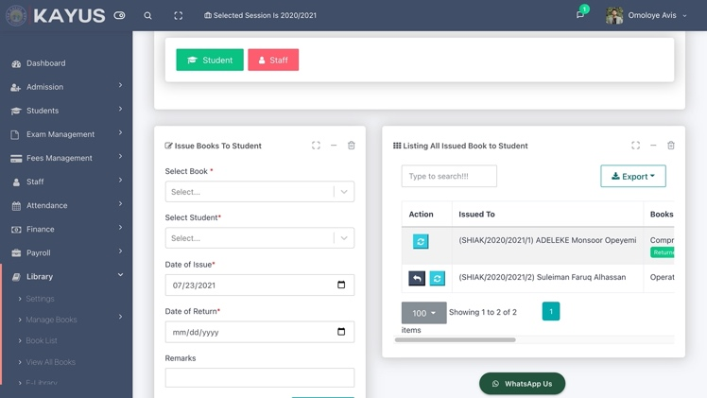The sub features includes:

1. Library Administration
2. Cataloging
3. Circulation
4. Borrowed Book List
5. Borrowers List
6. Book usage History

# Time Table Management System

Using the timetable module, the class teacher can set up class time table, create activities and add subject topics.

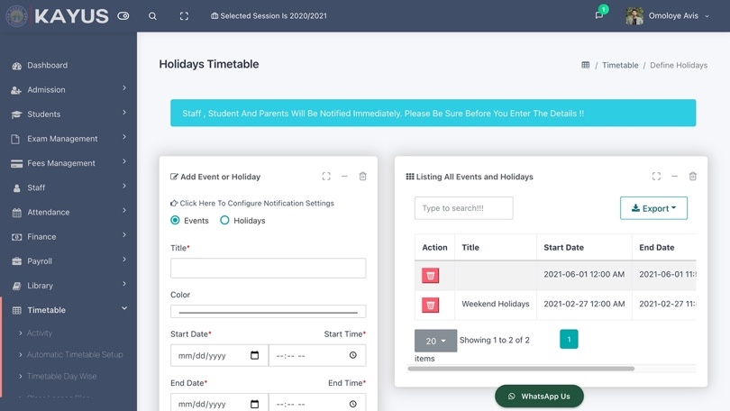Authorized users can

1. Set up a lesson plan
2. Define Holidays
3. Create Staff Schedules
4. Set up an event
5. Send Auto Notification to Staff, Students and Parents.

# Transport Management System

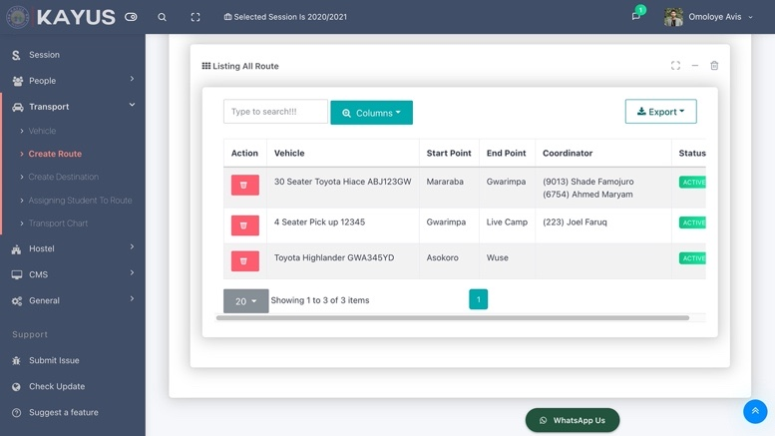

With the Transportation system, one can create routes, create vehicles and assign drivers to vehicles. Also, each student can be assigned to their pickup and drop locations

# Hostel Management System

The Hostel Module is a one-of-a-kind module that allows students to be assigned to a hostel and a room. This may be used to assign Wardens to hostels and keep track of visitors. When students book a hostel room, an Administrator must approve the booking before the room may be assigned. It is possible to pay hostel fees and renew your hostel membership online.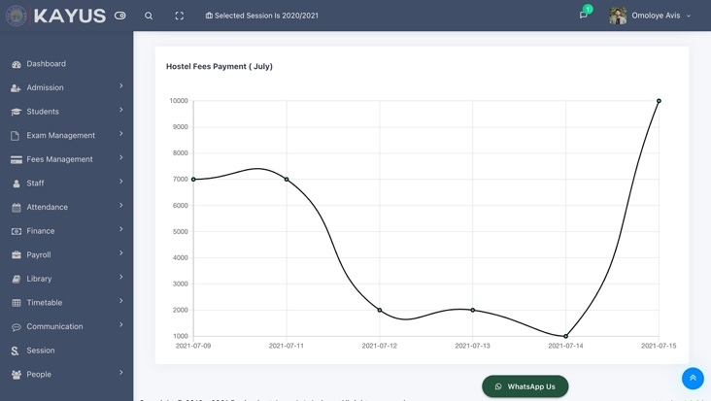

The sub features includes:

1. Hostel History
2. Vacate or Occupy Hostel room
3. List of rooms and capacity per hostel
4. **Assets Management Module**

This is a module that manage school properties, all asset can be recorded here and easily track their location. With this module one can record repair history, assign asset to staff and get life expectancy of an assets.

# 3.0 TECHNICAL SPECIFICATIONS

# 3.1 Summary of Functions

KAYUS is user-friendly, zero-paper processes in all its operational levels. It does not only enhance school management but also gives a competitive edge over its competitors with a reduced cost thus:

1. Determines the statistical information at a glance via reports.
2. Automates and integrates all processes in the school for better efficiency and flexibility.
3. Generates Academic reports such as broadsheet, subject result sheet, class result sheet and many more
4. Students/Pupils and teachers can view their personal, financial and academic information through the system.
5. Shares academic resources through its library system
6. KAYUS can be simply adjusted to follow the school's rules, laws, and policies regarding admissions, exams, student promotions, and attendance, among other things.

# 3.2 Testing, Installation and Training

We'll thoroughly test each module for functionality, accessibility, and browser compatibility for all text and visuals, ensuring that they meet your requirements and display as expected. At most three days of training on portal usage will be offered to the Portal Administrator, Staff, and Students to ensure that they can navigate the system with ease. This will increase their ability to provide content to the system. The final solution, as well as all supporting documentation, will be delivered to the School for evaluation, testing, and migration.

# 3.3 Performance

The system's design and platform take advantage of the most recent advancements in computer technology. The system features a graphical user interface that is totally web-based and user-friendly, as well as a report writer that allows users to create their own reports. Technically, the software is sound and virtually bug-free.

# PRODUCT ACTIVITIES

The system price is negotiable. The below table describes the system installation durations.

|  |  |  |
| --- | --- | --- |
| **No** | **Description of Activities** | **DURATION** |
| **A** | 1. Hosting and Server Configuration 2. Bulk SMS Account Creation 3. Online Payment Platform Integration 4. Email Delivery API Integration 5. Backup Tools Account 6. Google Analytics Setup | 2 Days |
| **B** | 1. Software Installation 2. Data Collection 3. System Verification and Modification 4. Trainings | 7 Days |
| **C** | 1. Feedbacks 2. Supports 3. Bug Fix 4. Updates | 5 Days |
|  | **TOTAL** | **14 DAYS** |

**Note: Domain + Hosting would be provided by the client.**

# 4.1 Term of Payment

This proposal does not include a cost estimate for the entire project. The manner of payment will be determined by the mode of deployment. The school can decide on the mode of deployment after they are satisfied.

# 4.2 Demo Version

Admotron Solutions recognizes your goal to provide cutting-edge technology to your institution. Our products are capable of withstanding competition in any climate. We may offer a free trial version of KAYUS with no strings attached. Surprisingly, the Demo Version is an exact clone of the full version. As a result, you will have the option to test all aspects of the System as well as request additional features at your leisure.

**4.3 Mode of Deployment**

Admotron Solutions run different mode of deployment; any choosing options can be negotiated further. Your school can choose from options below:

1. **Termly Payment (TP):** Admotron Solutions will offer all required materials free of charge. Both the running and the maintenance will be completed. The student will only be charged for an access token once every term. This access token can be as little as (N500) or as much as (N1000).
2. **Session Payment (SP):** Admotron Solutions will offer all required materials free of charge. Both the running and the maintenance will be completed. The school will only be charged for a subscription fee each session. This subscription fee can be as little as (N1500) or as much as (N3000).
3. **One time off**: A school can opt to pay one off and take ownership of the system. Typically, one-offs sell for as little as (N1,000,000) and as much as (N5,000,000).

# 5.0 KAYUS Portfolio

Admotron Solutions has created a wide range of websites across numerous industries utilizing a variety of platforms during the last five years. We'd like to highlight a few institutions that is currently using KAYUS. Furthermore, you will be familiarized with identical standards to those found on the Organization's website.

# 5.1 ADUVIE INTERNATIONAL SCHOOL

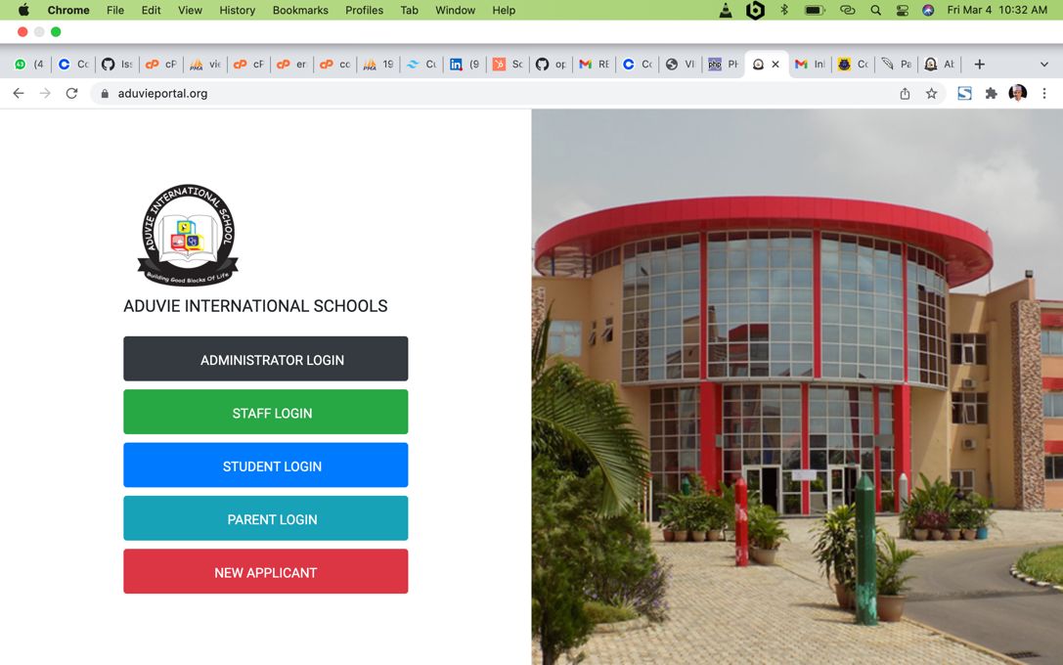

Aduvie won for two consecutive years “The Nigerian Advancement Award for Best Performing Primary School in Abuja”. She is also a recipient of the prestigious 2014 African Achievers' Award under the category tagged “Award for Quality Education in West Africa. Recently Aduvie adopted KAYUS as her school management system and it has been serving her seamlessly. The system has served the staff well and we continue to maintain and updated the system till date.

# 5.2 GAAT International School

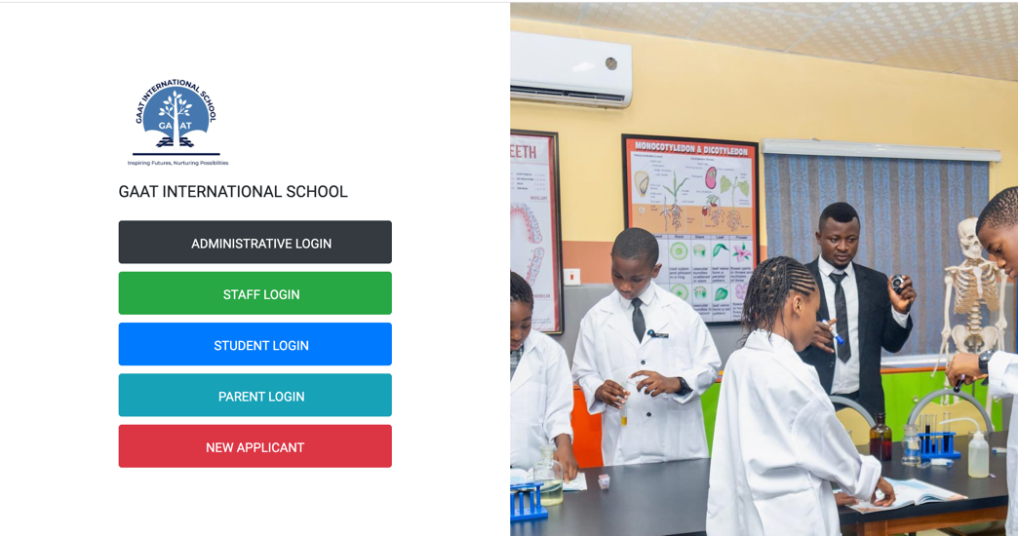Another development was when Admotron Solutions was contracted to integrate KAYUS to GAAT school. Specifically focused to manage Academics and Student registration. All graphics were provided and designed for the site and integrated to the database. We continue to provide content and SEO support for the system up until now.

# 5.3 PAGE SCHOOLS, APO

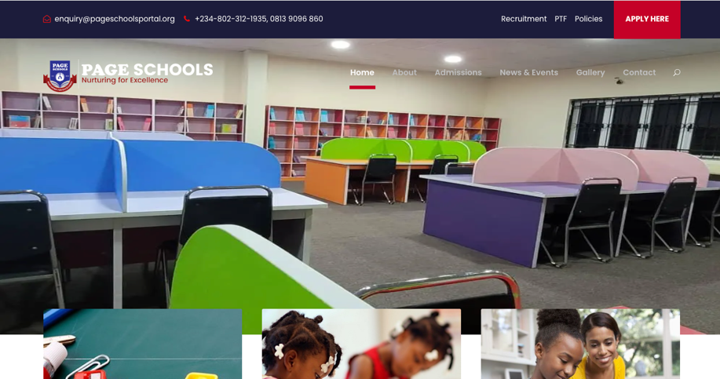Page is a brand-new School with State-of-the-art facilities, sited in a learner-friendly and serene environment and with highly qualified and experienced staff. Page School is one of the international schools that adopted KAYUS and currently using it.

# 5.4 GREAT MINDS MODEL INTELLECTUAL ACADEMY

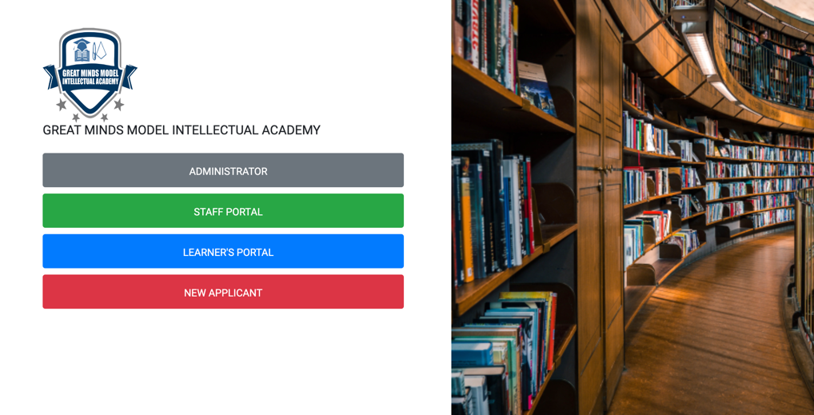Great Minds is one of the leading and most sought-after Nursery/Primary and Secondary School in Abuja. It was incorporated in Dei-Dei, Nigeria with registration number 2353946. In 2022, Great minds opt-in to use KAYUS and it has make their operation easier and smother. KAYUS team provides comprehensive staff training and also created a support group than response to complaint on time.

## **5.5 HASKE INTERNATIONAL SCHOOL, GORON DUTSE**

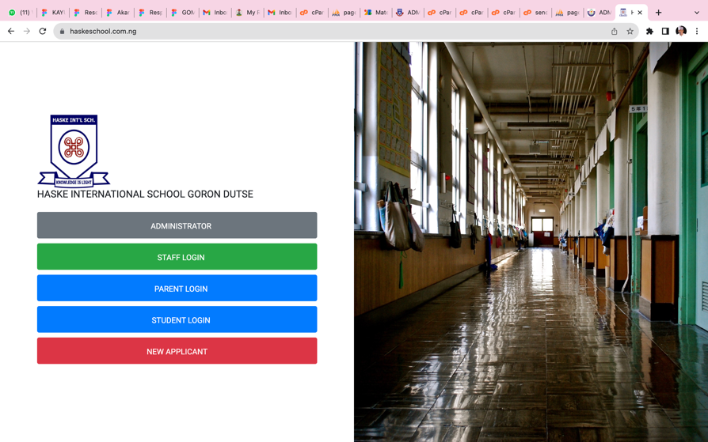HASKE International School was established in 2nd October, 2013 at No 675, Street 5, Behind Wreca Goron Dutse, Gwale Local Government Kano State. Admotron team was contracted to provide our expertise to HASKE. We develop their official website and also provide our KAYUS for their school management. We currently manage HASKE till date.

## **5.6 THE HERITAGE SCHOOL OF EXCELLENCE**

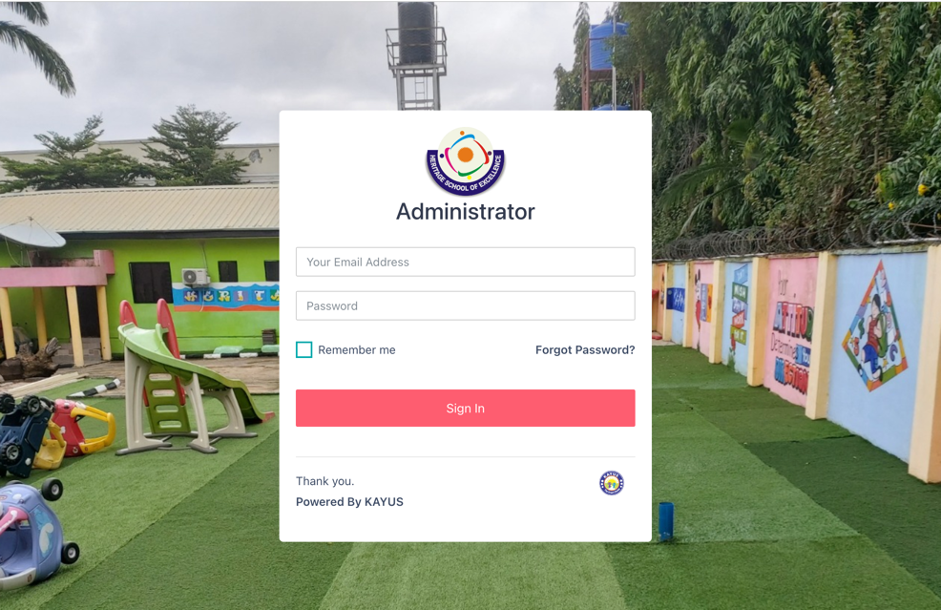The Heritage School of Excellence, is a modern and state of the art institution, she impact Knowledge and is a bridge to greatness. Admotron team provides comprehensive service, staff training and also created a support group than response to complaint on time for the Heritage School.

## **5.7 THE SOLID ROCK SCHOOL**

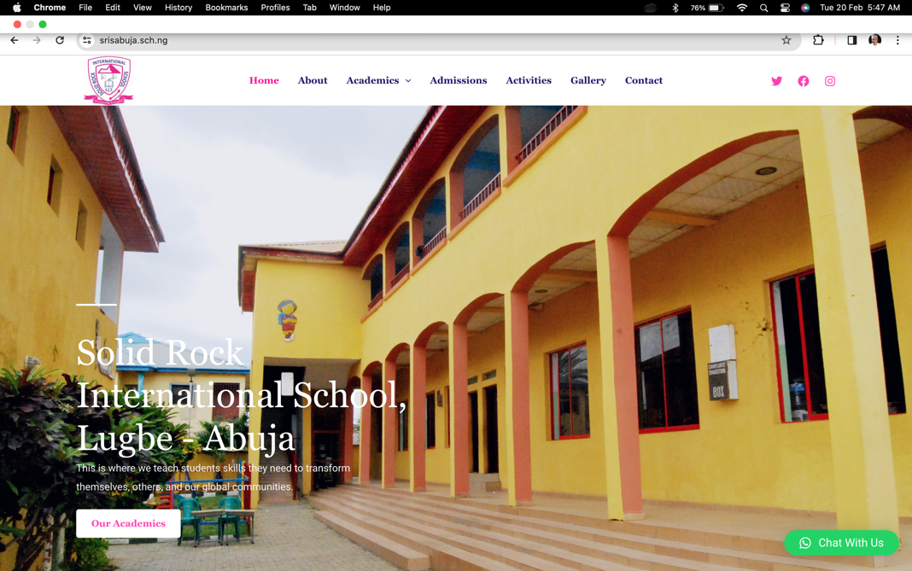Solid Rock International School offers a well-rounded curriculum that empowers students to dream big, learn continuously, take bold actions, and they have been doing this Since 1999. Solid Rock is the latest on our shelve. As we provide them with a comprehensive portal and management.

# 6.0 CONCLUSION

Current corporate competition can only be won by effectively managing available resources. Your school is a deserved winner with KAYUS. Admotron Solutions gives you this technology at a low cost to help you grow your business. If you grant us permission, you can rest assured that we will finish and deliver the system this academic term. This is to ensure that it is ready for the current academic term. We are available to answer any questions and look forward to meeting with you in person if you so desire. We look forward to hearing back from you on our proposal. You can get in touch with us via

Phone

**080-329-508-81**

Email

[**opeyemiademon@gmail.com**](mailto:opeyemiademon@gmail.com)

Social Media

[**https://www.twitter.com/adeMansoor**](http://www.twitter.com/adeMansoor)

You can call us to discuss and negotiate the price.

Thank You.





